**SYNOPSIS REPORT**

**ON**

**Smart Quiz Generator**

**B. TECH COMPUTER SCIENCE & ENGINEERING**



**Submitted by**

|  |  |
| --- | --- |
| **Gaurav Shukla** | 2000910100067 |
| **Divyansh Shandilya** | 2000910100062 |
| **Abhinav Garg** | 2000910100005 |
| **Divyam Dua** | 2000910100061 |

**Project Supervisor: Mrs. Surekha M**

**Department of Computer Science and Engineering**

**JSS Academy of Technical Education, Noida**

**October 2024**

**TABLE OF CONTENTS**

|  |  |  |
| --- | --- | --- |
|  | **Topic** | **Page** |
| 1 | INTRODUCTION |  |
| 2 | MOTIVATION |  |
| 3 | OBJECTIVES |  |
| 4 | SCOPE OF THE PROJECT |  |
| 5 | RELATED WORK |  |
| 6 | HARDWARE & SOFTWARE REQUIREMENTS |  |
| 7 | PREDICTED TIMELINE FOR PROJECT |  |
| 8 | CONCLUSION |  |
| 9 | REFERNCES |  |

**Introduction**

Questions serve as fundamental tools for assessing a learner's knowledge and understanding, playing a pivotal role in the educational process. Assessment is a critical aspect of learning, and questions are indispensable for this purpose. Multiple choice questions (MCQs) have emerged as the most prevalent form of assessment across various educational levels. They offer several notable advantages, including expedited evaluation, reduced testing time, consistent scoring, and the ability to facilitate electronic assessments. In fact, many examinations now rely on MCQ-based question papers, administered in a computerized environment, to efficiently evaluate large numbers of students.

However, manually crafting MCQs can be a time-consuming and expensive task. In response, the research community has dedicated substantial effort to developing methods for the automated generation of MCQs. This has led to the creation of numerous MCQ generation systems tailored to a variety of languages, domains, and educational applications. These systems have significantly transformed the assessment landscape by enhancing efficiency and accessibility while ensuring the integrity of the evaluation process. As technology continues to advance, the automated generation of MCQs is poised to become an even more essential and widespread component of educational assessment, ultimately benefitting both educators and learners.

**Motivation**

In the dynamic landscape of education and assessment, the integration of cutting-edge technology is essential for advancing learning and evaluation methodologies. Our Smart Quiz Generator represents a pioneering step in this direction, offering a powerful solution for harnessing the capabilities of Natural Language Processing (NLP) to transform text and PDF documents into dynamic quizzes.

One of the most compelling motivations behind this innovation is its potential to foster self-analysis. By enabling individuals to generate personalized quizzes from their own study materials, we empower them to take control of their learning journey. This promotes deeper comprehension, retention, and self-assessment, ultimately leading to improved academic outcomes and a more robust understanding of the subject matter.

Furthermore, our Smart Quiz Generator is a game-changer for educators and institutions. It streamlines the arduous process of question paper generation, significantly reducing the time and effort required. The automated evaluation capabilities alleviate the burden of manual grading, offering educators more time for pedagogical activities and personalized student support. This is especially crucial in today's fast-paced educational environment, where efficiency and adaptability are paramount.

By bridging the gap between traditional teaching and the possibilities of advanced technology, our Smart Quiz Generator promises a more efficient, insightful, and productive educational landscape. Join us in embracing the future of learning and assessment, where human effort is enhanced, not replaced, by the capabilities of NLP.

**Objectives**

* To take large PDF text input from user.
* To generate organized PDF of MCQ Question Answer pairs.
* To create a quiz from the PDF for the assessment.
* To analyze the results of the quiz.

**Scope**

The scope of our Smart Quiz Generator is wide-ranging, offering a versatile tool that harnesses Natural Language Processing (NLP) to revolutionize various aspects of education and assessment:

* Efficient Test Generation: The primary scope of this technology is to facilitate the creation of quizzes and tests, whether for classroom assessments or self-analysis. Educators and students can upload text or PDF documents, and the Smart Quiz Generator will automatically extract relevant questions and generate quizzes, significantly reducing the time and effort traditionally required for this task.
* Enhanced Self-Analysis: The tool enables individuals to create personalized quizzes from their study materials, fostering self-assessment and deeper learning. This feature empowers learners to take control of their educational journey and identify areas where they need improvement.
* Streamlined Question Paper Creation: Educational institutions can benefit from the efficiency of our Smart Quiz Generator in generating question papers. The process is automated, reducing the workload on educators and allowing them to focus on teaching rather than administrative tasks.
* Automated Evaluation: The tool also has the potential for automated evaluation, which can significantly reduce the time and effort spent on manual grading. This can be a game-changer for institutions dealing with a high volume of assessments.
* Reduction of Unfair Means: By offering a legitimate and accessible source of assessment content, the Smart Quiz Generator can help combat academic dishonesty, as students are less inclined to rely on unauthorized sources for their quizzes and tests. This scope promotes fair and honest evaluation practices.

In conclusion, the scope of our Smart Quiz Generator encompasses a wide array of educational and assessment needs, ultimately reducing human effort while enhancing the quality and fairness of the evaluation process.

**Related Work/Literature Survey**

I can mention some related works in the field of AI-powered quiz generation based on my last training data up to September 2021.

Please note that there may have been new developments or projects since then. Khan Academy:

* Khan Academy provides personalized learning and assessment tools that generate quizzes and questions based on the user's progress and performance. It uses NLP and adaptive learning techniques.
* Quizlet: Quizlet is an online learning platform that offers various tools for creating quizzes, flashcards, and study materials. It utilizes user-generated content and NLP for generating practice questions.
* EdTech Platforms: Many educational technology platforms, such as Coursera, edX, and Udemy, incorporate AI-driven assessment tools. These platforms create quizzes and exams based on course content and student performance.
* AI-Powered Assessment Tools: There are specialized AI assessment tools like ProProfs and Mettl that employ NLP and machine learning to create adaptive quizzes and exams, assisting educators in generating assessments for various purposes.
* GitHub Projects: Some developers on GitHub have created open-source projects for AI-based quiz generation. These projects often leverage NLP libraries and machine learning algorithms for question generation.

While these related works may not match your specific project's capabilities and features, they are indicative of the broader landscape of AI-driven quiz and assessment generation tools in the educational technology domain. You may want to conduct a current web search to identify the latest projects and advancements in this field.

**Hardware & Software**

Hardware:

1. High-performance GPU (Graphics Processing Unit): Our project requires access to a high-performance GPU to accelerate the training and evaluation of deep learning models. An NVIDIA GeForce GTX 1080 or a more advanced GPU is ideal for this purpose. GPUs significantly speed up the processing of large medical datasets and complex neural network computations.
2. Computer System: A powerful computer system with ample RAM and storage capacity is essential for data management, model development, and dataset curation. The system should be capable of handling large volumes of medical data efficiently.

Software:

1. Python Programming Language: Python serves as the primary programming language for our project. It offers a rich ecosystem of libraries and tools, making it well-suited for deep learning development. We will leverage libraries such as TensorFlow and Keras to implement and train deep learning models.
2. Jupyter Notebook: Jupyter Notebook provides an interactive and user-friendly development environment for our project. It enables us to experiment with different model architectures, visualize results, and document the project's progress effectively.

**PREDICTED TIMELINE FOR PROJECT**

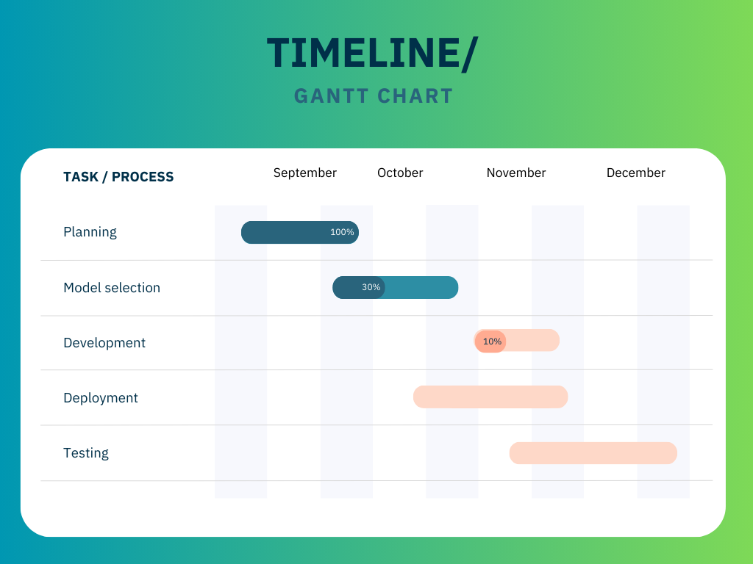

**Conclusion**

Evaluation is critical in the teaching-learning process, and multiple-choice questions (MCQs) are commonly used in educational assessment. We reviewed the efforts on automatic MCQ generation from text provided in the literature in this paper. We talked about the various methods for creating MCQs that are currently in use. We created a generic workflow that included six broadly grouped dependent phases: preprocessing, sentence selection, key selection, question construction, distractor generation, and postprocessing. For the implementation of the individual phases, various strategies have been used. We gave a comparison of various methods. We also talked about how to evaluate MCQs created by the system. In this System, we reviewed the works on automatic MCQ generation from text that have been presented in the literature. We talked about the various methods for creating MCQs that are currently in use. Pre-processing, sentence selection, key selection, question construction, distract or generation, and post-processing are the six broadly classed dependent phases that we established

**REFERENCES**

1. Nikahat Mulla & Prachi Gharpure “Automatic question generation: a review of methodologies, datasets, evaluation metrics, and applications” in Prog Artif Intell 12, 1–32 (2023). https://doi.org/10.1007/s13748-023-00295-9
2. Bidyut Das, Mukta Majumder, Santanu Phadikar & Arif Ahmed Sekh “Automatic question generation and answer assessment: a survey” in RPTEL 16, 5 (2021). https://doi.org/10.1186/s41039-021-00151-1
3. Ghader Kurdi, Jared Leo, Bijan Parsia, Uli Sattler & Salam Al-Emari “A Systematic Review of Automatic Question Generation for Educational Purposes” in International Journal of Artificial Intelligence in Education 30, 121–204 (2020). https://doi.org/10.1007/s40593-019-00186-y
4. Girish Kumar BC, Aditya Kumar Gupta, Arpita Verma, Devansh Chaudhary & Rajneesh Pandey “An Encrypted Automatic Multiple-Choice Question Generator for Self-Assessment Using Natural Language Processing” in JETIR Journal of Emerging Technologies and Innovative Research (JETIR) 2022 JETIR May 2022, Volume 9, Issue 5.
5. Dhawaleshwar Rao, CH Sujan Kumar Saha, “Automatic Multiple Choice Question Generation,” in IEEE Journal, IEEE TRANSACTIONS ON LEARNING TECHNOLOGIES, VOL. 13, NO. 1, JANUARY-MARCH 2020.
6. Riken Shah, Disha Shah, “Automatic Question Generation for Intelligent Tutoring System,” in IEEE Journal, 2017 2nd International Conference on Communication Systems, Computing, and IT Applications (CSCITA).
7. Mushale Ashish, Shafali Gupta, “An automatic generator of multiple-choice question with random answer key,” JETIR June 2020, Volume 7, Issue 6.
8. M. Agarwal and P. Mannem, “Automatic gap-fill question generation from textbooks,” in Proceedings of the 6th Workshop on Innovative Use of NLP for Building Educational Applications, ser. IUNLPBEA ’11. Stroudsburg, PA, USA: Association for Computational Linguistics, 2011.
9. Afzal, N. and Mitkov, R. (2014) ‘Automatic generation of multiple-choice questions using dependency-based semantic relations’, Soft Computing - A Fusion of Foundations, Methodologies and Applications.
10. M. Agarwal and P. Mannem, “Automatic Gap-fill Question Generation from textbooks,” Proceedings of the Sixth Workshop on Innovative Use of NLP for Building Educational Applications, Jun. 2011.
11. P. Pabitha, M. Mohana, S. Suganthi, and B. Sivanandhini, “Automatic Question Generation system,” 2014 International Conference on Recent Trends in Information Technology, 2014.
12. D. Lindberg, F. Popowich, J. Nesbit, and P. Winne, “Generating natural language questions to support learning on-line,” in Proc. 14th Eur. Workshop Natural Lang. Gener., 2013.
13. A. Hoshino and H. Nakagawa, “A real-time multiple-choice question generation for language testing: A preliminary study,” in Proc. 2nd Workshop Building Edu. Appl. Using NLP, 2005.
14. D. Pugh, A. De Champlain, M. Gierl, H. Lai, and C. Touchie, “Using cognitive models to develop quality multiple-choice questions,” Med. Teacher.
15. M. Majumder and S. K. Saha, “A system for generating multiple choice questions: With a novel approach for sentence selection,” in Proc. 2nd Workshop Natural Lang. Process. Techn. Edu. Appl., 2015
16. I. Aldabe, M. L. de Lacalle, M. Maritxalar, E. Martinez, and L. Uria, “Arikiturri: An automatic question generator based on corpora and NLP techniques,” in Proc. 8th Int. Conf. Intell. Tutoring Syst., 2006.
17. C. Kwankajornkiet, A. Suchato, and P. Punyabukkana, “Automatic multiple-choice question generation from Thai text,” in Proc. 13th Int. Joint Conf. Computer. Sci. Softw. Eng., 2016.
18. R Mitkov, L. An Ha, and N. Karamanlis, “A computer-aided environment for generating multiplechoice test items,” Natural Lang. Eng., vol. 12, no. 2, Jun. 2006.
19. J. Araki, D. Rajagopal, S. Sankarnarayanan, S. Holm, Y. Yamakawa, and T. Mitamura, “Generating questions and multiple-choice answers using semantic analysis of texts,” in Proc. Int. Conf. Computer. Linguistics, 2016. [16] B. Sun, Y. Zhu, Y. Xiao, R. Xiao, and Y. G. Wei, “Automatic question tagging with deep neural networks,” IEEE Trans. Learn. Technology